**A**

**PROJECT REPORT**

**ON**

# “FITCLUB GYM”

**For**

**SYBBA(CA)**

**Submitted By**

Jiya Agarwal - 3202

**SUBMITTED TO**

# Vishwakarma College of Arts, Commerce & Science.

# Shanti Nagar Kondhwa, pune-411048



Bansilal Ramnath Agarwal Charitable Trust



**VISHWAKARMA COLLEGE OF ARTS, COMMERCE SCIENCE, PUNE**

Kondhwa Bk., Pune-411048

CERTIFICATE

**This is to certify that,**

**Mr./Mrs.________________________________________________**

**Of______________________________class has completed project**

**Report on_______________________________________________**

**________________________________________________________**

**Practical work in the Department of_________________________ As prescribed by the Savitribai Phule University, in the academic year 2023-2024.**

**Principal Internal Examiner External Examiner**

**Date:**

**Remark:**

ACKNOWLEDGEMENT

I extend our deepest appreciation to my esteemed guide, **Ritika Choudhary** for providing me with the possible to complete this project with the right guidance and advice.

Special gratitude I give to my respected head of the Department **Dr Sudhir Chitnis**, for allowing me to use the facilities available and also help me to coordinate my project. Furthermore, I would also like to acknowledge with much appreciation the crucial role of faculty member on this occasion.

Last but not least, I would like to thank friends who help me to assemble the parts and gave a suggestion about the project.

DECLARATION

I the undersigned hereby declare that the project work entitled “_______________” submitted to the Savitribai Phule, Pune University is the record on an original work done by me for the partial fulfilment of: Bachelor of Business Administration (Computer Application) Academic year 2023-2024 under the guidance of Ritika Choudhary. Findings and conclusions are based on the material collected by me. This project has not been submitted or published on any other college or institutes before.

Student Name:

Roll No:

Class & Sem: SYBBA(CA) Sem-IV

Seat No:

Date:

Place:

Index

|  |  |  |
| --- | --- | --- |
| Sr. No | **Particulars** | **Page No.** |
| **1** | ABSTRACT | 6 |
| **2** | **2.1** INTRODUCTION  **2.2** Motivation  **2.3** Problem Statement  **2.4** Purpose / Objective and Goals  **2.5** Literature Survey  **2.6** Project Scope and Limitation  **2.7** Methodology | 7-13 |
| **3** | System Analysis  **3.1** Existing System  **3.2** Project Perspective: Features  **3.3** Stakeholders  **3.4** Requirement Analysis | 14-16 |
| **4** | System Design  **4.1** ER Diagram  **4.2** DFD Diagrams  **4.3** System flow Diagram  **4.3** User Interface (input and output screen) | 17-37 |
| **5** | Implementation Details  **5.1** Software/Hardware Details | 38 |
| **6** | Conclusion | 39 |
| **7** | Future Scope | 40 |
| **8** | Bibliography | 41 |

1 ABSTRACT

In today's health-conscious society, fitness has become an integral part of people's lifestyles, prompting the proliferation of gym websites as essential tools for accessing fitness resources and services. It explores the multifaceted role of gym websites in facilitating personalized fitness experiences, fostering community engagement, and harnessing emerging technologies to optimize user outcomes. Through an examination of key features, functionalities, and future prospects, this abstract provides insights into the evolving landscape of gym websites as dynamic platforms for empowering individuals on their fitness journey.

Our gym website is a dynamic platform designed to transform the fitness landscape by offering innovative solutions to common challenges faced by enthusiasts. Through streamlined scheduling, personalized progress tracking, and vibrant community engagement features, users are empowered to optimize their fitness journey like never before. Beyond convenience, our platform prioritizes inclusivity and support, fostering a sense of belonging and camaraderie among members. By harnessing the power of technology and community, we aspire to inspire lasting lifestyle changes and promote holistic well-being among our users.

2.1 INTRODUCTION

This document outlines the project details and specifications for the development of a gym website. The website aims to provide information about the gym's facilities, services, class schedules, membership options, and online booking capabilities.

Welcome to our Fitclub Gym, where fitness meets excellence! Our state-of-the-art facility is dedicated to help you to achieve your health and wellness goals.

Discover the ultimate destination for your fitness journey at Fitclub Gym. Our dynamic community, top-notch facilities, and personalized training programs are designed to empower you to reach your fitness goals. Ready to get started? Take the first step towards a healthier, stronger you just by clicking the registration button below, you'll unlock access to our comprehensive registration page where you can kickstart your fitness journey. Fill out the form with your details to get started on your path to a healthier lifestyle.!

Congratulations on completing the registration process, now you'll be redirected to our vibrant home page, where you'll find a wealth of resources, including equipment’s, different types of classes and support system. Welcome to our fitness family – let's embark on this exciting journey together!

On our Home page, you'll find our friendly chat bot ready to assist you with any inquiries you may have. Simply type your question, and get instant assistance without having to leave the page. Experience seamless support at your fingertips with our intuitive chat bot feature.

As you navigate through our website, you'll come to a BMI calculator after visiting the Home Page. Simply input your height and weight to determine your Body Mass Index (BMI) and gain insight into your overall health.

Explore the exceptional amenities and state-of-the-art equipment available at our facility on our dedicated 'Facility' page. From cutting-edge workout machines to specialized training areas. Discover the variety of spaces tailored to enhance your workout experience at Fitclub Gym: Cardio Area, Free Weight Area, Cycling Studio, Weight Lifting, Locker Room, Lounge, Multipurpose Hall, Strength Area. At FITNESS GYM, we're committed to providing you with the ultimate fitness environment to support your goals.

At FITclub GYM, we're committed to providing you with the ultimate fitness environment to support your goals.

Explore our flexible membership plans tailored to fit your fitness needs at FITclub Gym: -

Gym Membership: Access to our gym equipment’s, including cardio, weightlifting, and personalized trainers too.

Yoga Membership: Immerse yourself in the calming practice of yoga with flexible class timings and featuring a variety of classes suitable for all levels, from beginner to advanced.

Zumba Membership: Dance your way to fitness with our high-energy workout Zumba classes, where fun meets effective calorie burning.

Clicking the *'Enroll Now*' button will guide you to our secure payment gateway, where you can conveniently enter your payment details to finalize your membership.

Discover the inspiring stories and successes of our valued members on our Testimonials page. Hear firsthand accounts of transformation, determination, and achievement as individuals share their fitness journeys with us. From weight loss milestones to personal triumphs, let their experiences motivate and inspire you on your own path to wellness.

Our About Us page introduces our gym's mission, values, and team of expert trainers who are dedicated to helping you achieve your fitness goals.

After exploring our mission, team, and offerings, head to our Contact page to connect with us directly. We look forward to hearing from you!

2.2 MOTIVATION

Gym websites address the evolving needs of individuals seeking convenient access to fitness resources and services. Leveraging digital technologies, they offer personalized guidance, immersive experiences, and community engagement, empowering users to achieve their fitness goals effectively and sustainably.

The gym website serves as a dynamic virtual gateway, offering a myriad of functionalities and resources aimed at empowering individuals on their fitness journey. Whether it's exploring class schedules, booking sessions, accessing expert advice, or connecting with a supportive community, the gym website transcends geographical boundaries to deliver an immersive fitness experience tailored to diverse preferences and goals.

Our gym website is motivated by a desire to address common challenges faced by fitness enthusiasts, such as cumbersome scheduling processes, lack of progress tracking tools, and limited community interaction. By offering intuitive features and a user-friendly interface, we aim to empower users to take control of their fitness journey and achieve their goals more effectively. Additionally, we are motivated by the opportunity to foster a sense of belonging and support within our fitness community, encouraging members to connect, inspire, and motivate each other on their path to health and wellness.

2.3 PROBLEM STATEMENT

To create a dynamic and user-friendly website for Fitclub Gym that effectively showcases its services, facilities, and class schedules, while also providing a platform for online membership registration and class bookings. The website should be responsive, engaging, and reflective of Fitclub Gym's brand identity, ultimately enhancing the overall user experience and increasing customer engagement.

2.4 PURPOSE/OBJECTIVE & GOALS

Objectives**: -**

Create a user-friendly website interface for easy navigation and accessibility.

Provide comprehensive information about the gym's offerings, including classes, trainers, and facilities.

Implement online booking and scheduling features for classes and appointments.

Increase visibility and attract new members through effective marketing and promotion strategies.

Enhance communication and engagement with current members through the website.

Goals: -

**Enhance Accessibility**: The primary goal is to make fitness resources and services more accessible to individuals, regardless of their location, schedule, or fitness level.

**Provide Personalization**: The goal is to offer personalized fitness experiences tailored to individual goals, preferences, and abilities.

**Foster Engagement**: Another goal is to foster engagement and participation among users by providing interactive features, community forums, and social networking capabilities.

**Promote Long-Term Health**: Ultimately, the overarching goal is to promote long-term health and well-being among users by encouraging regular physical activity, healthy lifestyle habits, and a positive mindset towards fitness.

2.5 LITERATURE SURVEY

The literature survey on gym websites encompasses a wide range of studies, articles, and publications that examine various aspects of fitness websites, including their design, functionality, user experience, and impact on health behaviors.

**Key themes and findings from the literature survey may include: -**

**Website Design and Usability**: Studies have evaluated the design elements and usability features of gym websites, such as navigation, layout, visual aesthetics, and mobile responsiveness. Research suggests that user-friendly websites with intuitive interfaces are more likely to attract and retain users.

**Personalization and Tailored Content**: Researchers have investigated the importance of personalized content and tailored recommendations in motivating users to engage with fitness websites. Studies have shown that customized workout plans, nutrition advice, and goal-setting features can enhance user satisfaction and adherence to exercise routines.

**Community and Social Support**: The literature highlights the significance of social support and community engagement in driving user motivation and adherence to fitness goals. Research suggests that gym websites with community forums, social networking features, and peer support mechanisms can foster a sense of belonging and accountability among users.

**Technology Integration and Innovation**: Scholars have explored the role of emerging technologies, such as artificial intelligence, virtual reality, and wearable devices, in enhancing the functionality and effectiveness of gym websites. Studies have demonstrated the potential of technology-driven interventions to improve user engagement, provide real-time feedback, and optimize fitness outcomes.

**Health Behavior Change and Impact**: Literature on gym websites often examines their impact on health behavior change, physical activity levels, and overall well-being. Research findings may include evidence of positive associations between website usage, exercise adherence, and improvements in fitness-related outcomes.

2.6 PROJECT SCOPE & LIMITATION

Scope: -

**Modern Website Design**: Create a modern, visually appealing website design that reflects the energetic and motivating atmosphere of Fitclub Gym.

**Membership Management**: Implement a system for online membership registration, renewal, and payment.

**Trainer Profiles**: Include profiles of trainers with photos to showcase the expertise of Fitclub Gym's staff.

**SEO Optimization**: Optimize the website for search engines to improve its visibility and ranking in search results.

**Content Management System (CMS)**: Implement a CMS that allows staff to easily update website content, such as class schedules and trainer profiles.

Limitations: -

**Budget**: The project budget may limit the scope of the website in terms of features and functionality that can be implemented.

**Time Constraints**: The project timeline may restrict the amount of time available for development and testing.

**Technical Constraints**: Technical limitations, such as compatibility with existing systems or software, may restrict the implementation of certain features.

**Security**: Ensuring the security of user data and transactions may impose limitations on the implementation of certain features.

**User Base**: The website may be designed to cater to a specific user base (e.g., gym members), which could limit its appeal to a broader audience.

2.7 METHODOLOGY

Agile methodologies are well-suited for web development projects because they emphasize flexibility, collaboration, and iterative development.

**Below is how we applied agile principles to this project**: -

**Define the Project Vision**: Start by defining the overall vision and goals for the project. This should align with the problem statement and the expectations of the stakeholders.

**Create a Product Backlog**: Develop a prioritized list of features and requirements for the website based on the requirement analysis. This will serve as the product backlog.

**Sprint Planning**: Break down the product backlog into smaller, manageable tasks and prioritize them for the first sprint. The sprint length can vary but is typically 1-4 weeks.

**Sprint Execution**: Develop the website features according to the tasks identified for the sprint. Daily stand-up meetings can help keep the team aligned and address any issues that arise.

**Sprint Review**: At the end of each sprint, review the work completed with stakeholders and gather feedback. Use this feedback to adjust priorities and plan the next sprint.

**Sprint Retrospective**: Hold a retrospective meeting after each sprint to reflect on what went well and what could be improved. Use this feedback to make adjustments for future sprints.

**Iterate**: Continue this cycle of planning, executing, reviewing, and iterating until all the features and requirements for the website have been implemented.

Agile methodologies allow for greater flexibility and responsiveness to changing requirements, which can be beneficial for our Fitclub Gym website, where requirements and priorities may evolve over time.

3 SYSTEM ANALYSIS

System analysis for the Fitclub Gym website project involves a comprehensive study of the current system (if any) and the requirements for the new system. This analysis helps in understanding the existing challenges and opportunities for improvement, as well as in defining the scope and objectives of the project.

**Here are some key steps in system analysis**: -

**Understanding Business Needs**: Identify the business goals and objectives of Fitclub Gym and how the website can support these goals. This involves discussions with key stakeholders to understand their requirements and expectations.

**Gathering Requirements**: Collect and document the functional and non-functional requirements for the new website. This includes features such as membership management, class scheduling, trainer profiles, and mobile responsiveness.

**Analyzing Current System**: If there is an existing website or system, analyze its strengths, weaknesses, opportunities, and threats (SWOT analysis). Identify areas for improvement and determine which features can be carried over to the new system.

**Defining Scope and Objectives**: Based on the requirements and analysis, define the scope and objectives of the project. This includes setting clear, achievable goals and establishing criteria for success.

**Creating System Design**: Develop a high-level design for the new system, including the architecture, database structure, user interface design, and integration with external systems (e.g., payment gateway).

**Evaluating Alternatives**: Consider different options for implementing the new system, such as using existing software solutions or developing a custom solution. Evaluate the pros and cons of each option based on the project requirements and budget.

**Risk Assessment**: Identify potential risks and challenges that may arise during the project and develop mitigation strategies to address them.

**Cost-Benefit Analysis**: Evaluate the costs associated with developing and implementing the new system against the expected benefits. This helps in determining the feasibility and ROI of the project.

**Documentation**: Document all findings, requirements, and design decisions to serve as a reference for the development team and stakeholders.

System analysis is a crucial step in the development process as it lays the foundation for the successful implementation of the Fitclub Gym website, ensuring that it meets the needs of the business and its customers.

3.1 EXITISING SYSTEMS

This mainly includes a basic website that provides some information about the gym, such as its location, contact details, and maybe a brief overview of its services. However, it may lack advanced features such as online membership registration, class bookings, detailed class schedules, trainer profiles, and interactive elements.

The existing website also have a design that is outdated and not optimized for mobile devices, which could result in a poor user experience for visitors trying to access the site from smartphones or tablets. Additionally, the lack of integration with a secure payment gateway may make it difficult for customers to sign up for memberships or book classes online.

Overall, the existing system for Gym website likely needs significant improvements to better meet the needs of its customers and improve the overall user experience.

3.2 PROJECT PERSPECTIVE: FEATURES

**Membership Management**: Allow users to sign up for memberships, renew or upgrade their plans, and manage their account details online.

**Accessibility and Usability Features**: Ensure the website is accessible to users with disabilities by incorporating features such as alternative text for images, keyboard navigation, and screen reader compatibility.

**Trainer Profiles and Services**: Showcase profiles of gym trainers, including their specialties, certifications, and availability for personal training sessions.

**Workout Plans and Resources**: Offer pre-designed workout plans, exercise routines, and instructional videos for users to follow at home or in the gym.

**Nutrition Guidance**: Provide nutrition tips, meal plans, and recipes to support users in achieving their fitness and wellness goals.

3.3 STAKEHOLDERS

**Gym Owners/Managers**: Owners or managers of the gym are primary stakeholders as they oversee the overall direction, strategy, and investment in the website project.

**Users/Members**: The users or members of the gym are crucial stakeholders as they are the primary audience for the website.

**Trainers/Instructors**: Trainers and instructors who work at the gym are important stakeholders as they play a key role in delivering fitness classes, programs, and services.

**Administrators/Staff**: Administrative staff are responsible for managing the gym's operations, membership, and scheduling the classes.

3.4 REQUIREMENTS ANALYSIS

**Stakeholder Identification**: Identify the key stakeholders involved in the project, such as gym owners, staff members, trainers, and gym members.

**Gathering Requirements**: Conduct interviews, surveys, and workshops to gather requirements from stakeholders.

**Prioritizing Requirements**: Prioritize requirements based on their importance to stakeholders and the overall goals of the project. Identify must-have features versus nice-to-have features.

**Creating Requirement Specifications**: Document the requirements in a detailed specification document. This document should include functional requirements (what the system should do) and non-functional requirements (how the system should perform).

**Review and Approval**: Review the requirement specifications with stakeholders to ensure they accurately reflect their needs and expectations. Obtain approval from stakeholders before proceeding to the design and development phase.

4 SYSTEM DESIGN

4.1 ER DIAGRAM

User

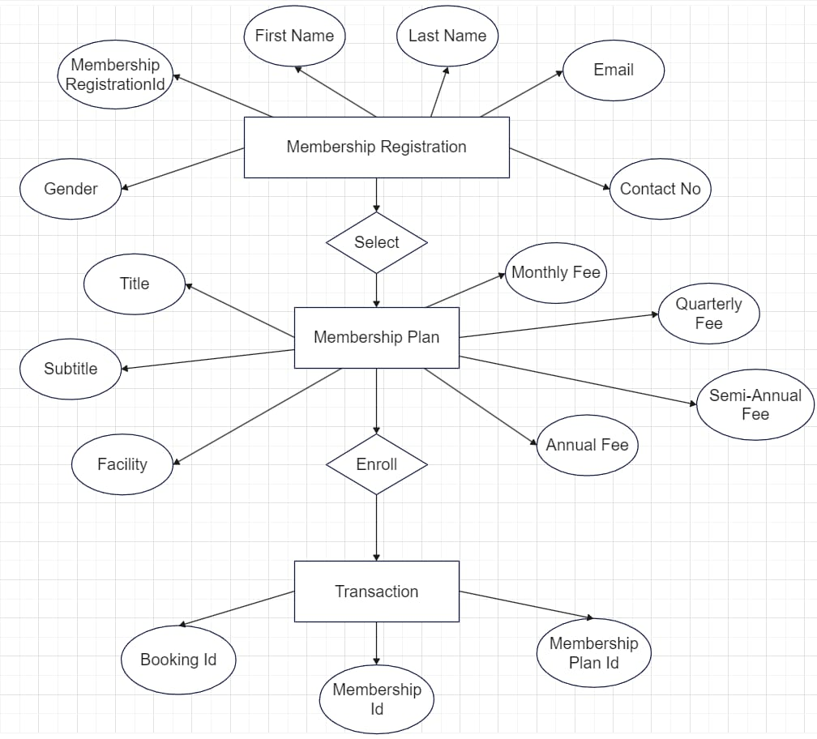

4.2 DFD DIAGRAM

**Level 0**

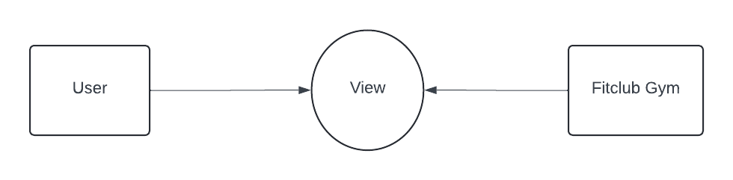

**Level 1**

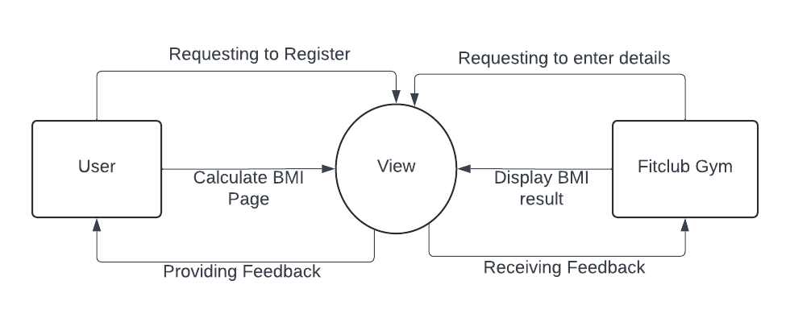

**Level 2**

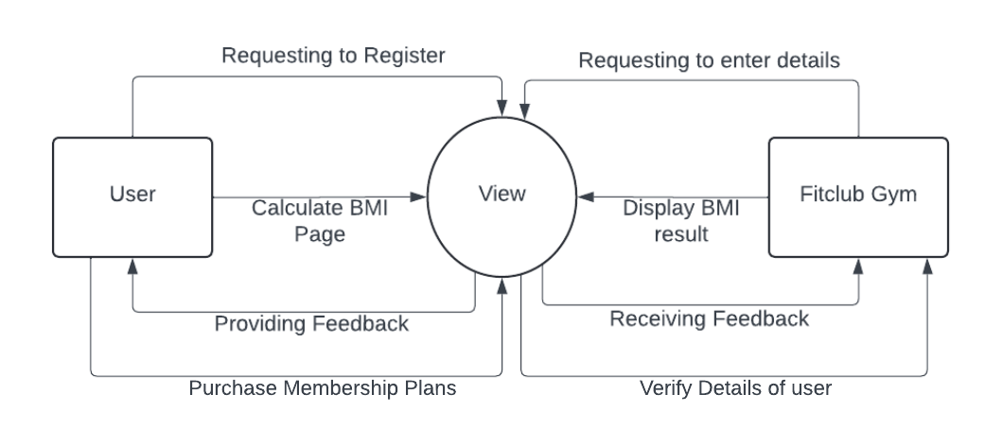

4.3 SYSTEM FLOW DIAGRAM

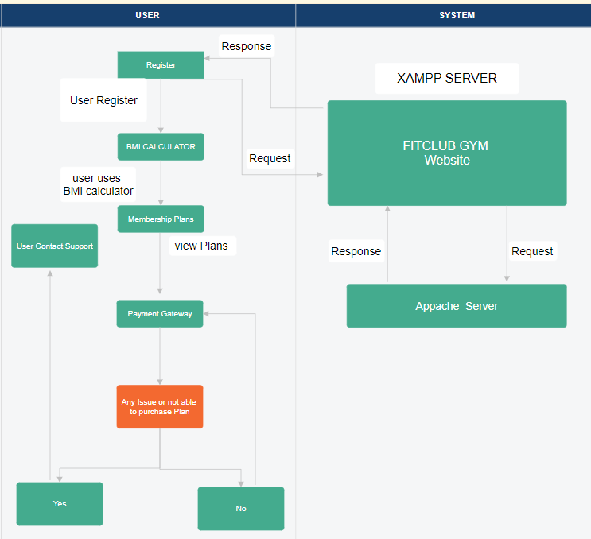

4.4 USER INTERFACE (INPUT & OUTPUT SCREEN)



This is the landing page where we have a short video of 4-5 secs.

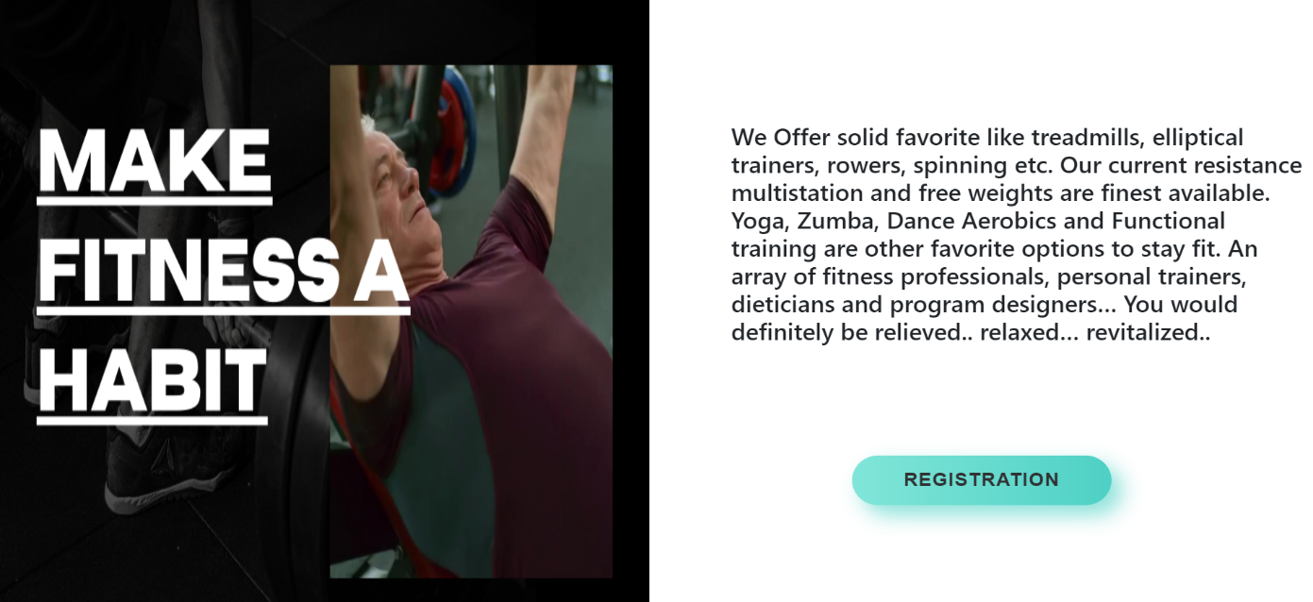

This is the continuation of landing page where we have a registration button.



This is the coding of Landing Page.



This is the registration page. The user has to fill their details.

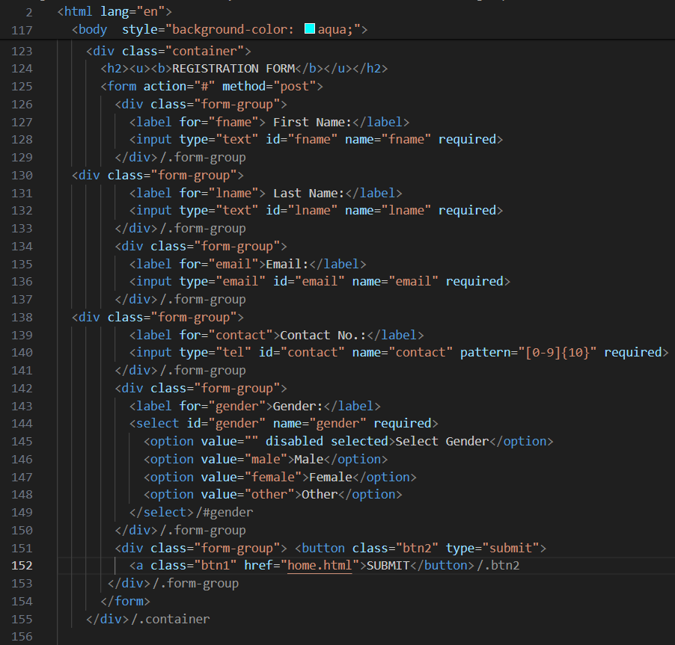

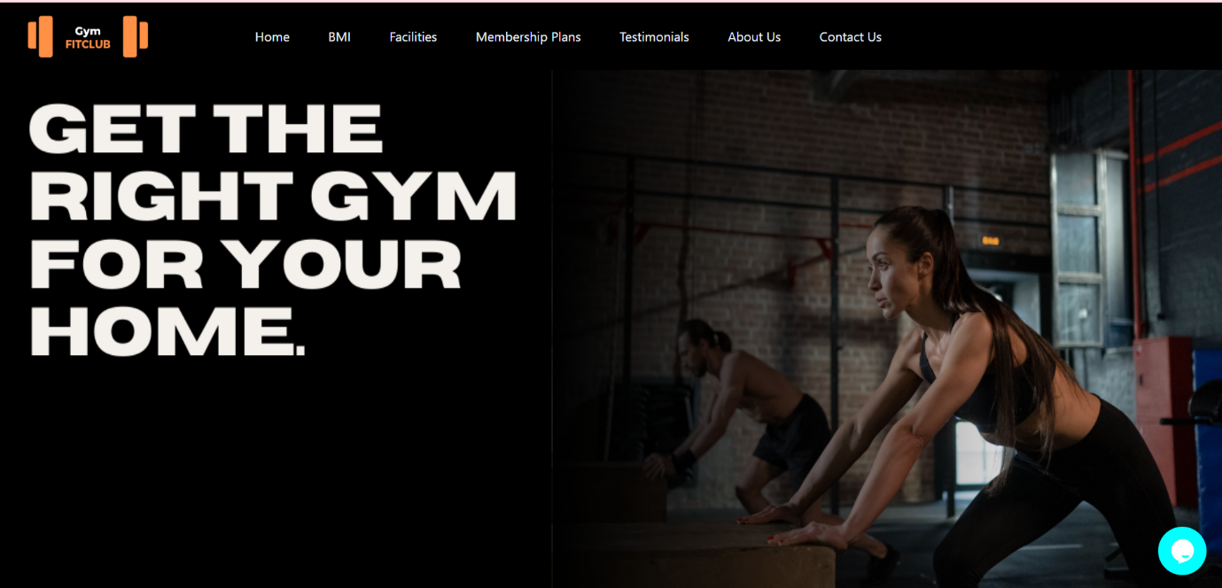

After filling the registration form the user will come on a home page.

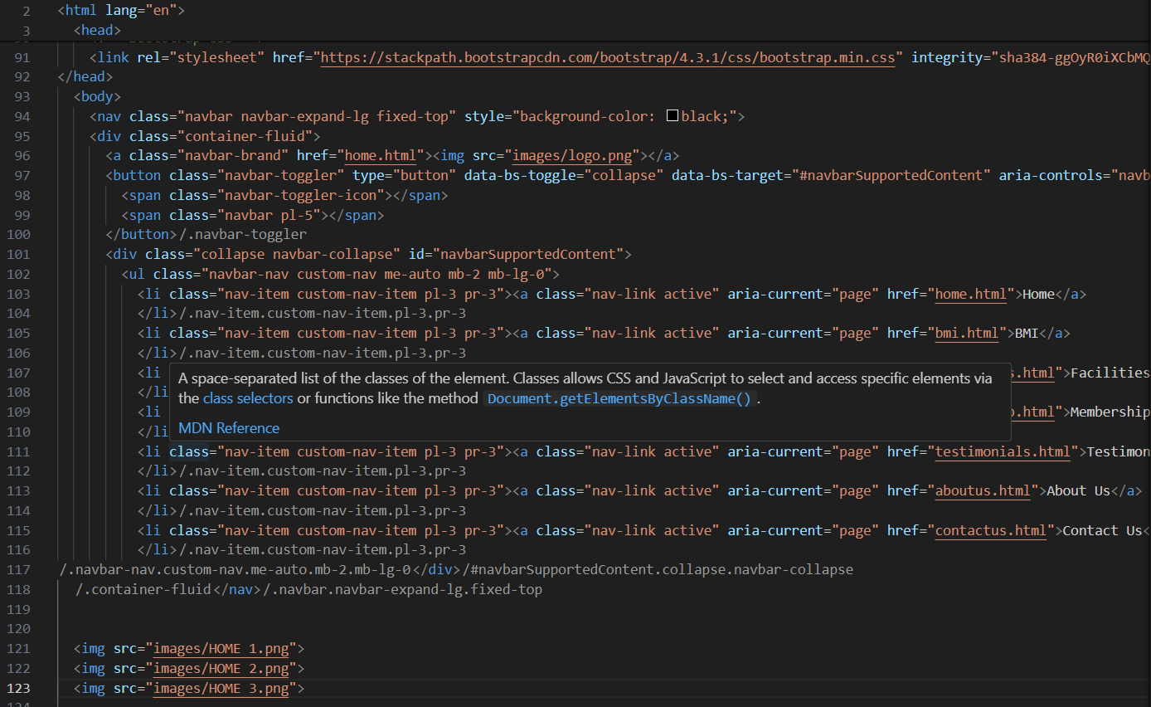

This is the Coding of Home Page.

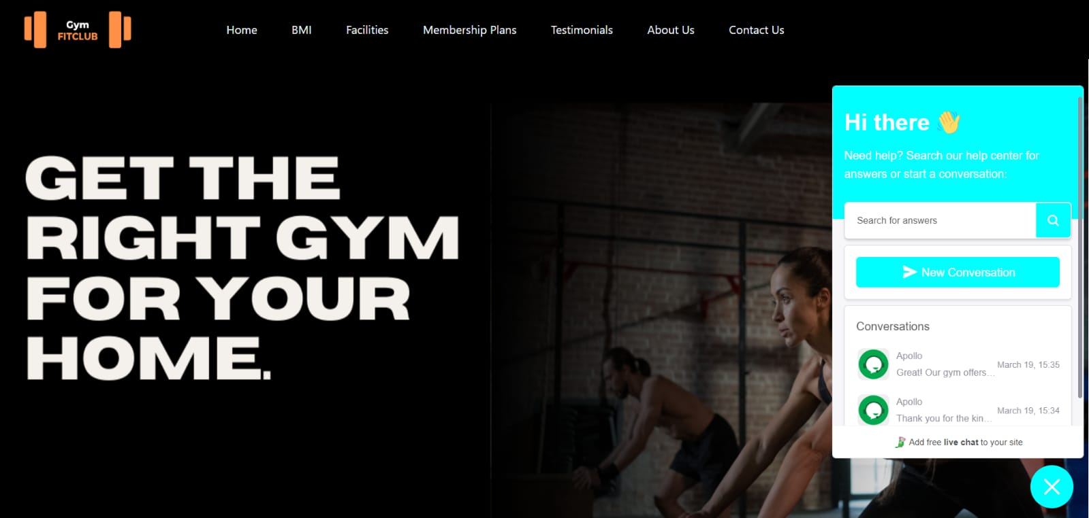

We have a chatbot too in our home page where the user can ask questions about the gym.

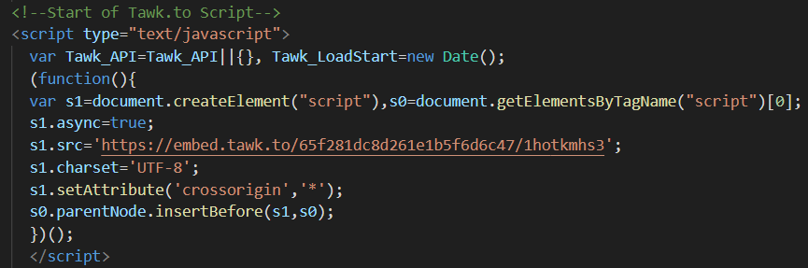

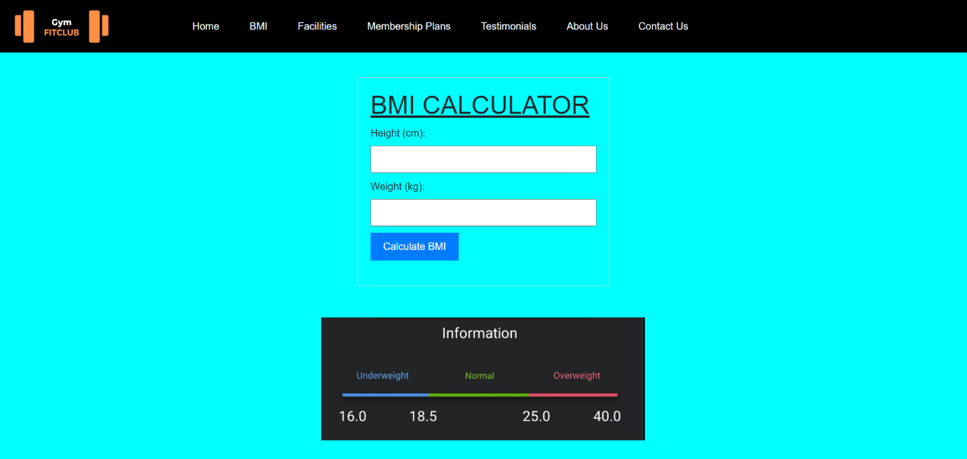

This is the BMI page where the user can calculate their height and weight and check their body type.

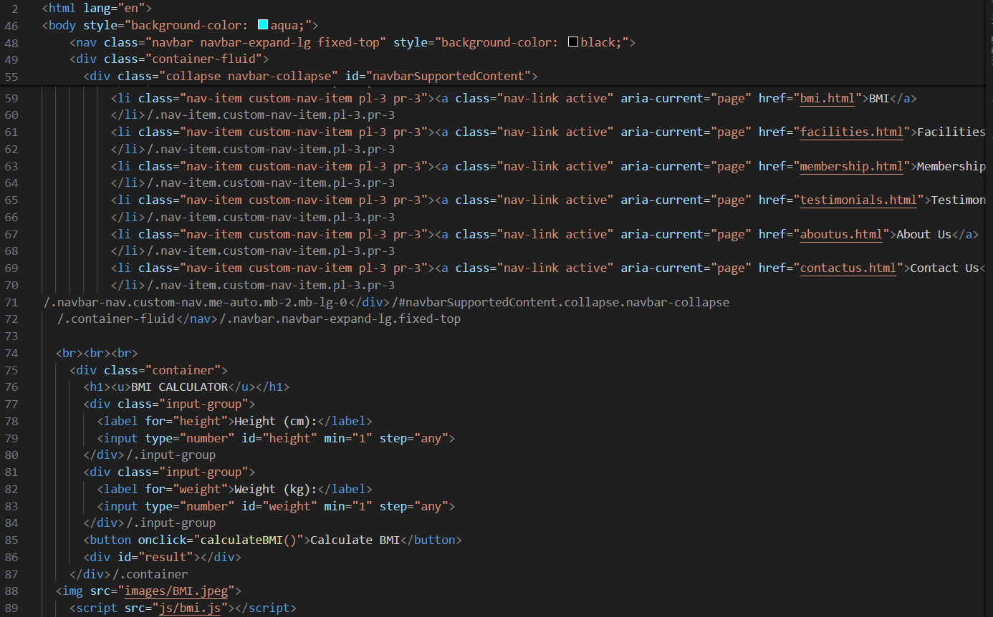

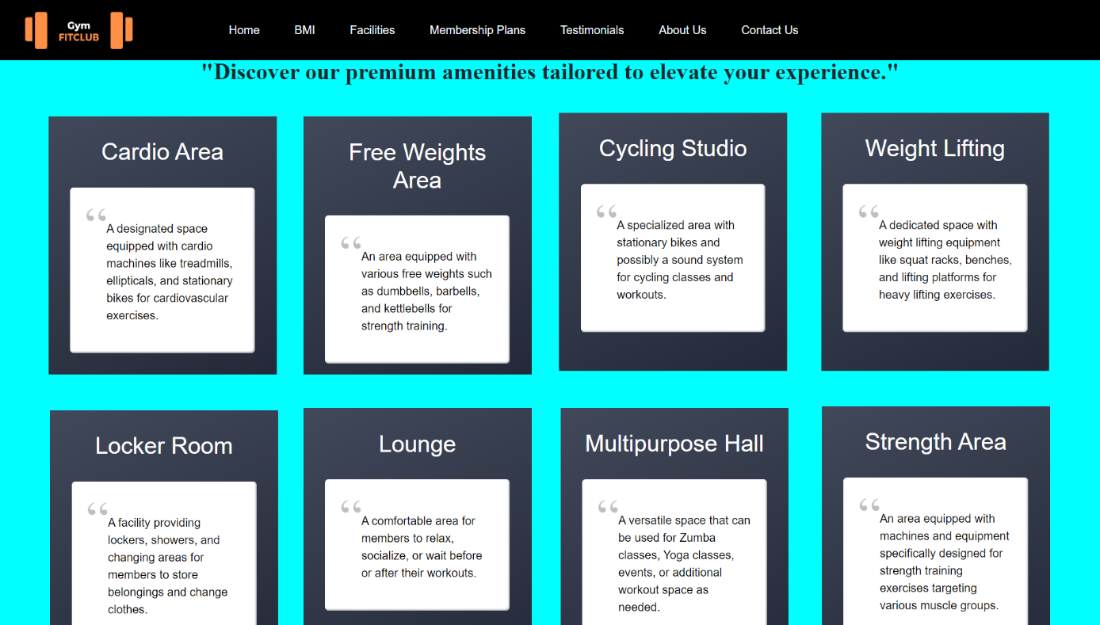

This is the facilities page where the user can get a complete information about the facilities provided in our gym.

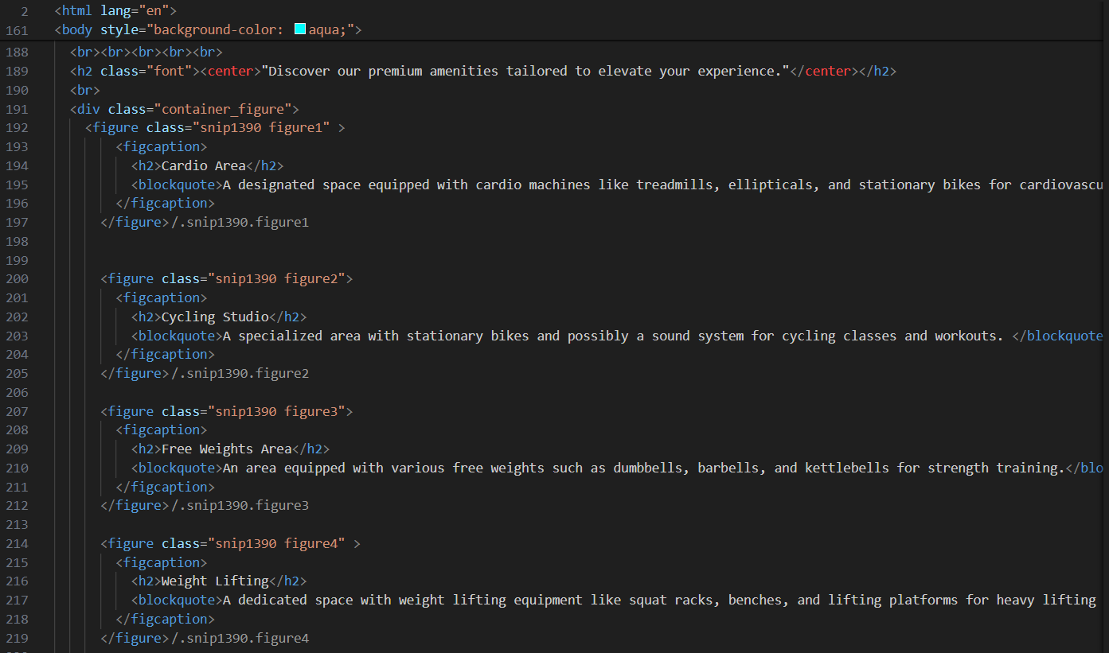

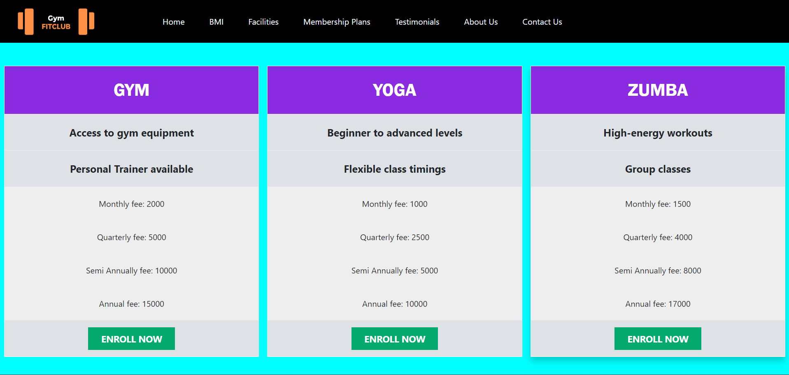

This is the membership plan page where the user can have a look about the plans and enroll for it.



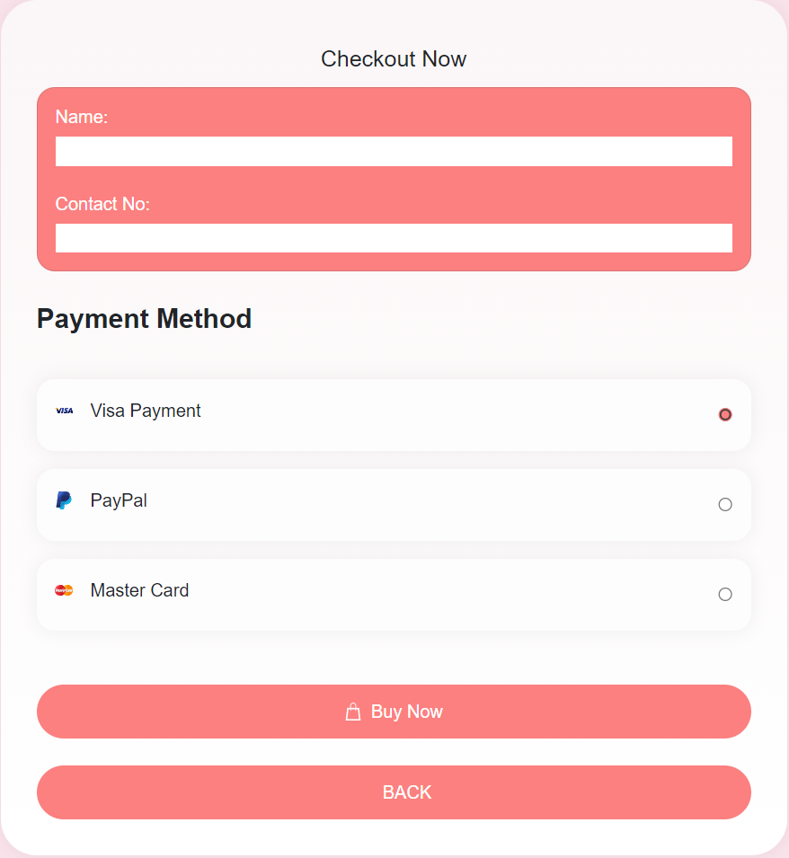

This is the payment page where the user can pay for a specific plan in which they are interested.

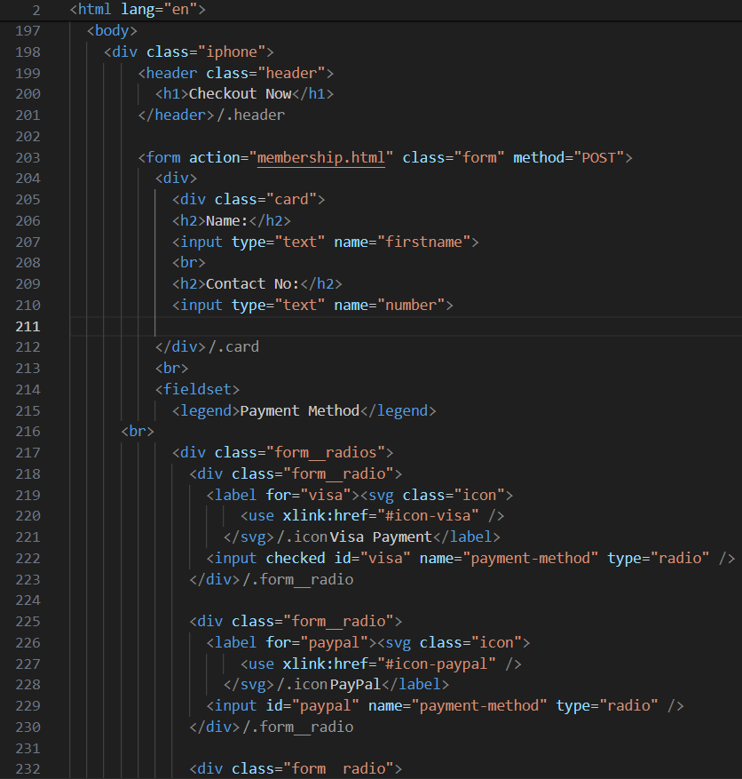

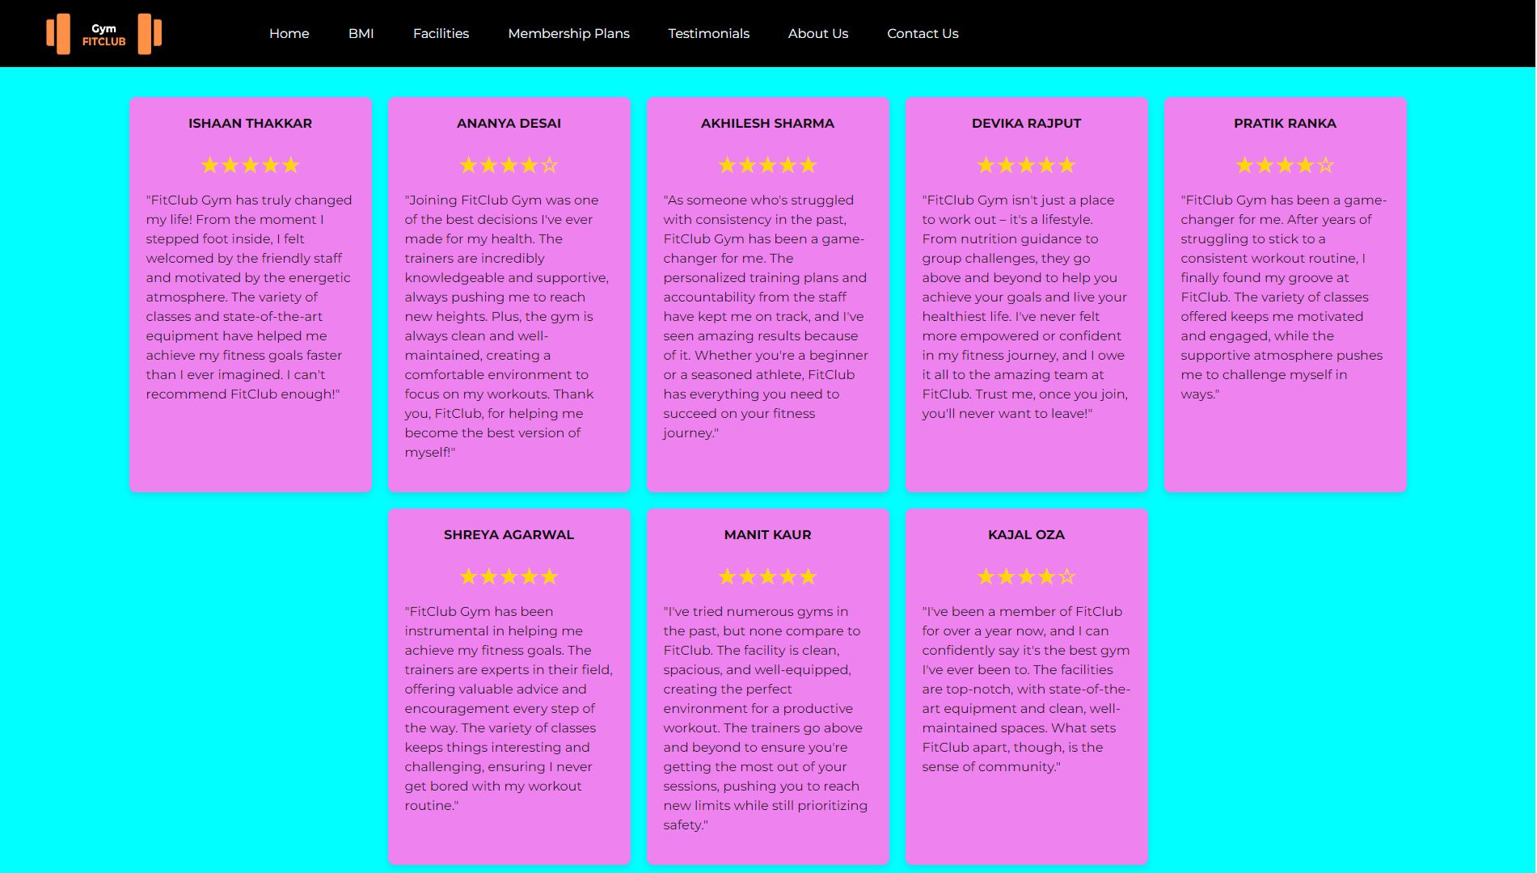

This is the testimonials page where we have reviews about our existing members or past members. New users can have a look on these reviews and decide it accordingly.



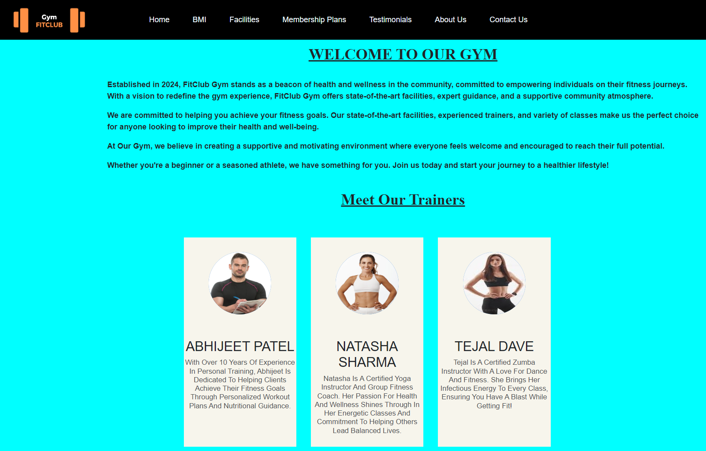

This is about us page where the user can get more knowledge about our gym and our Trainers.

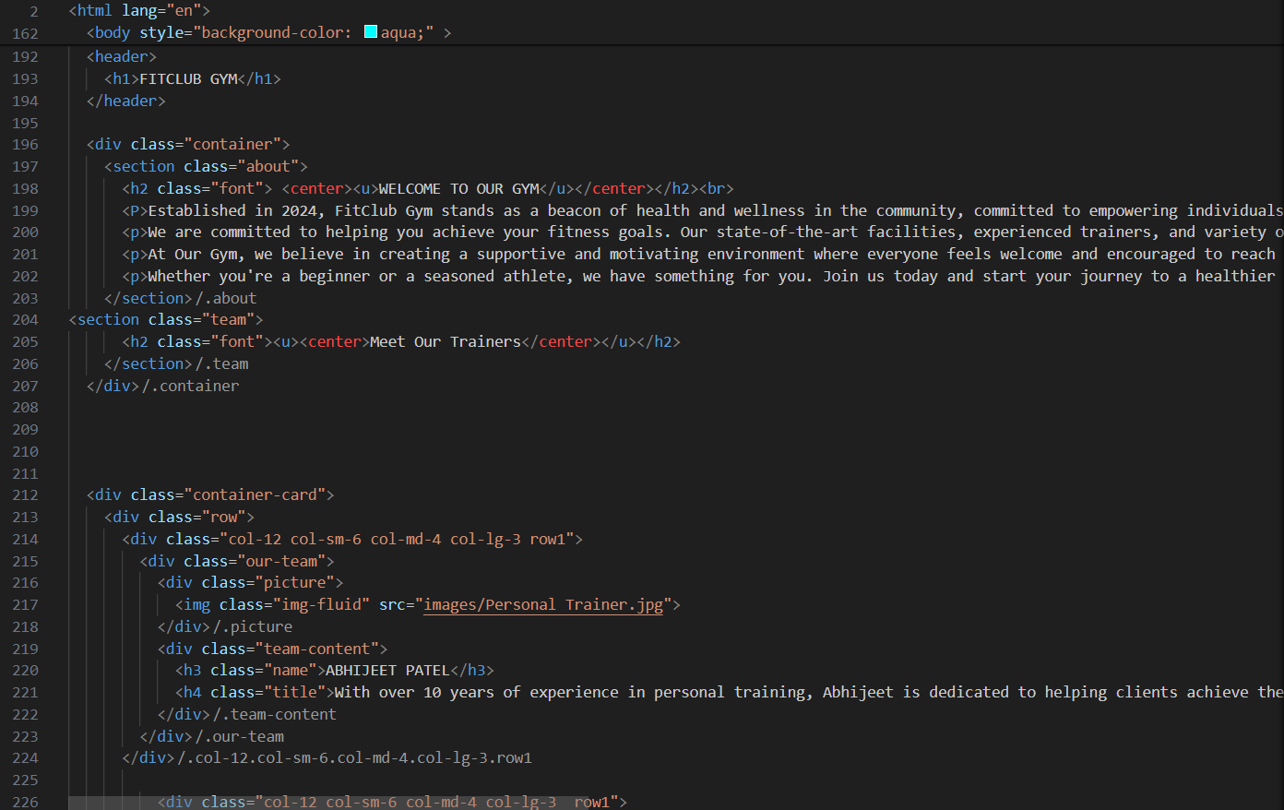

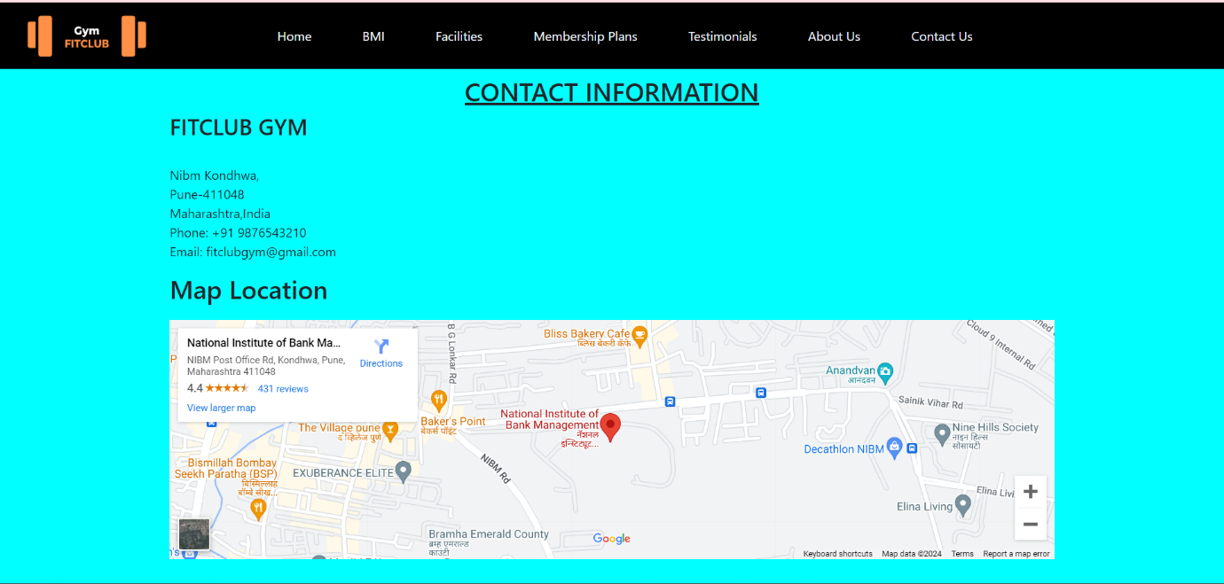

This is the contact us page where the user can easily contact us and get the location of our gym too.

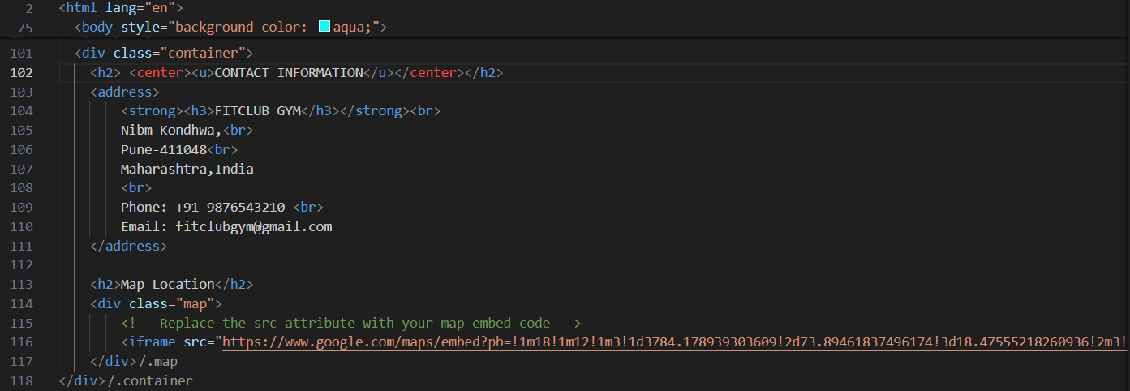

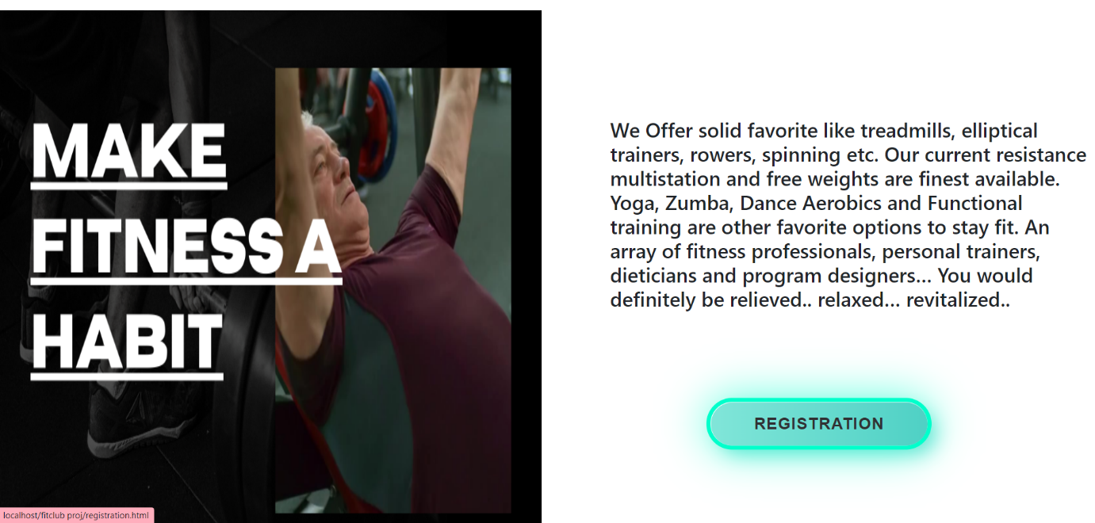

This is the output of landing page.



This is the output screen for registration page.

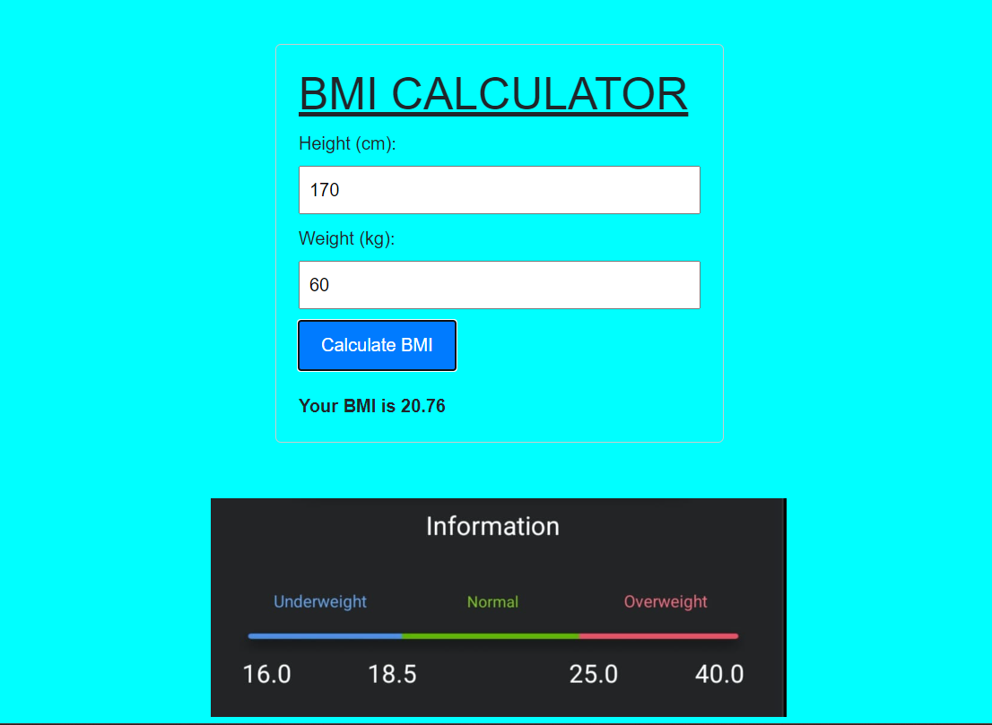

This is the output screen of BMI Calculator

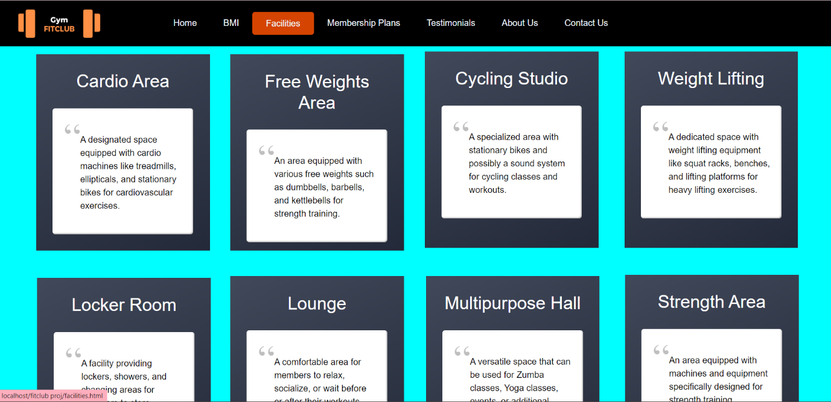

This is the output of facilities page.

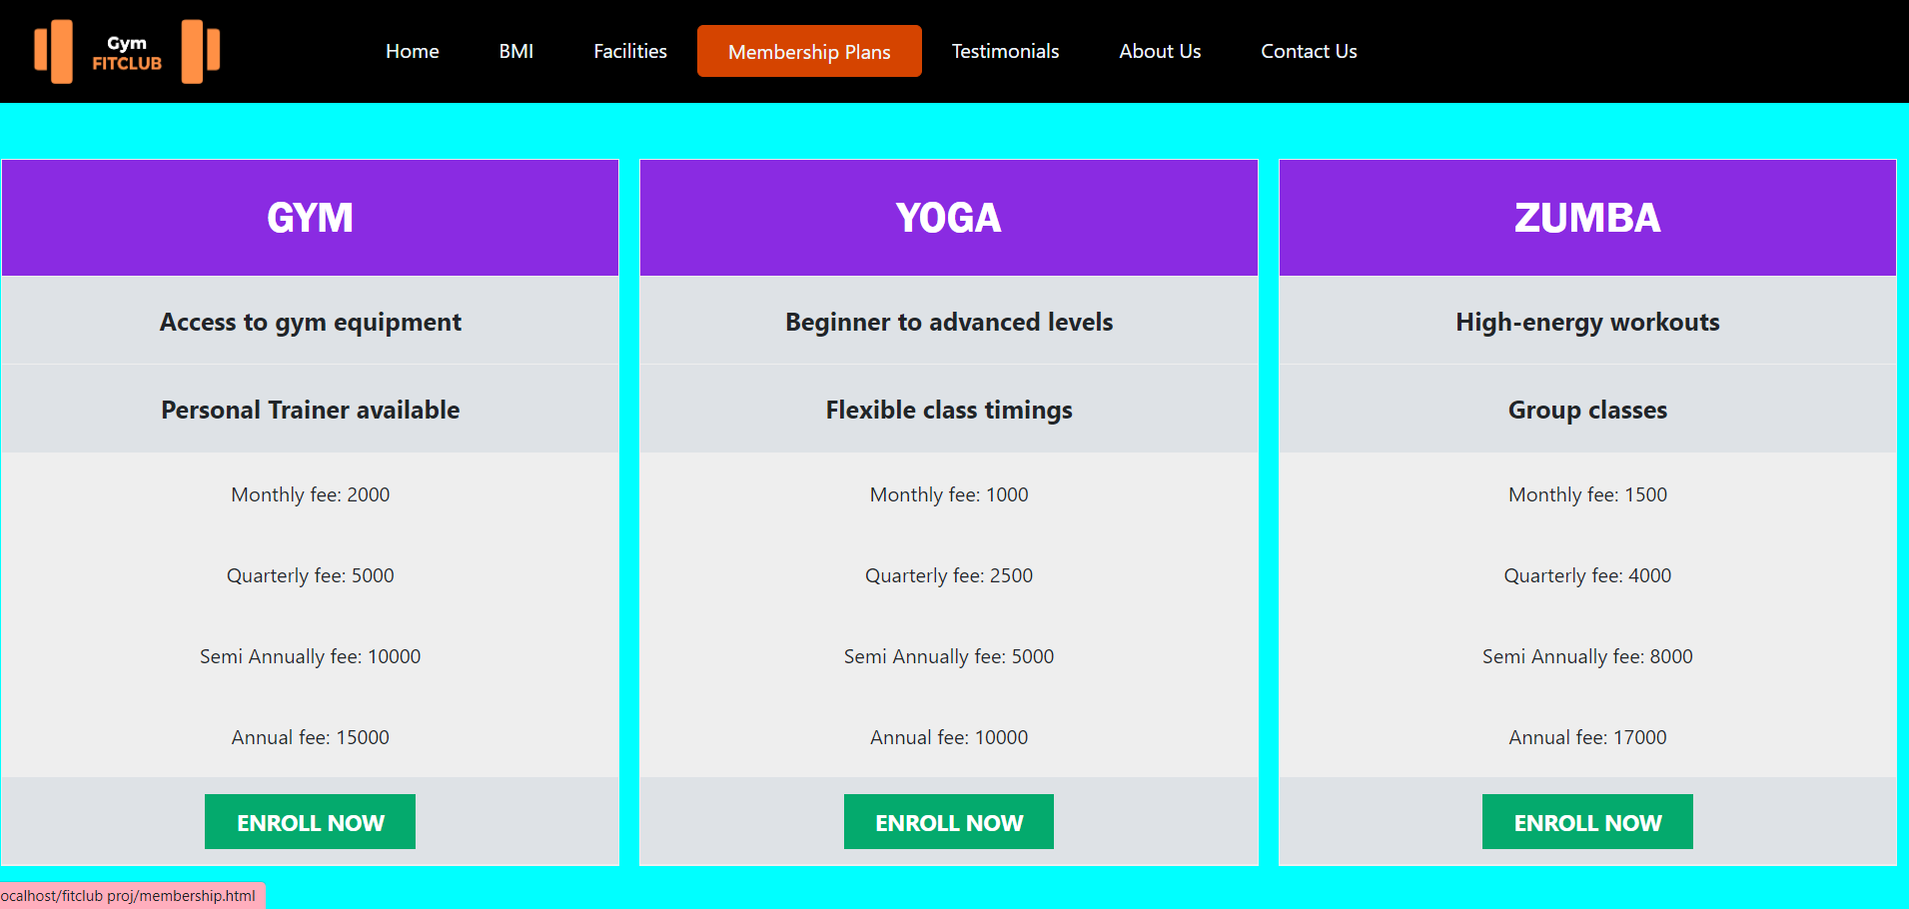

This is the output of membership page

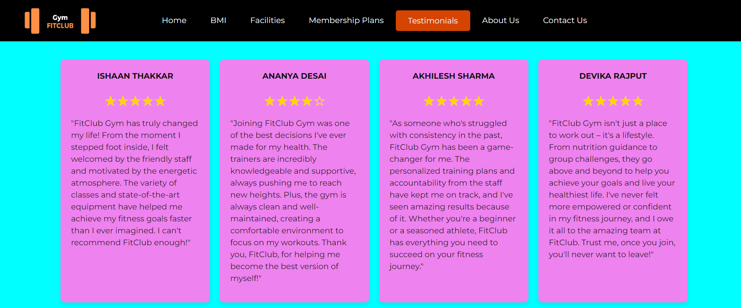

This is the output for testimonials page.

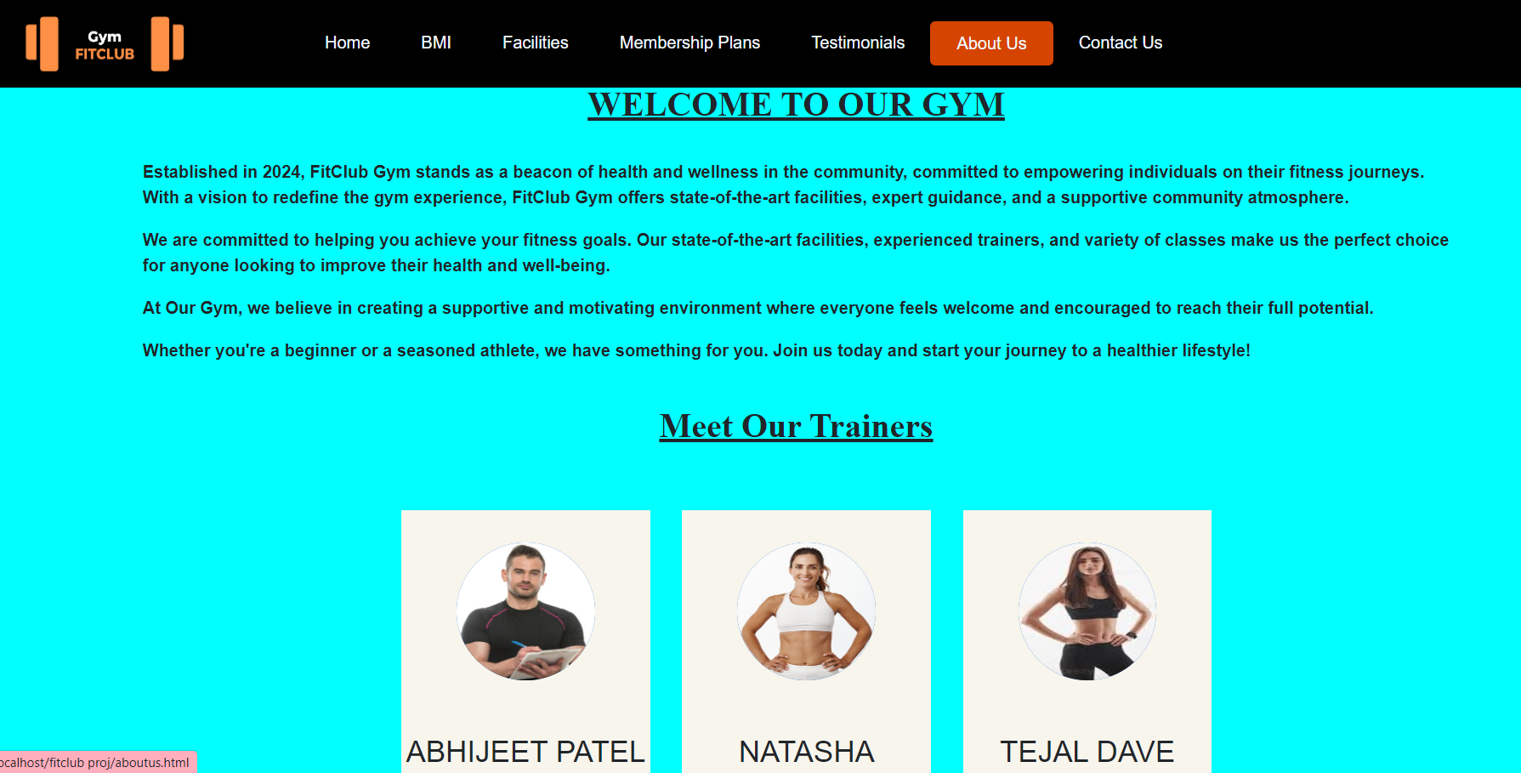

This is the output of about us page.

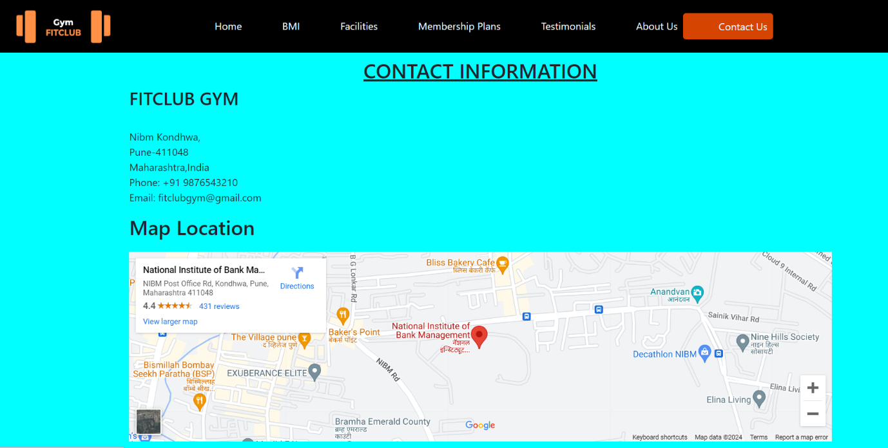

This is the output of contact us page.

5 IMPLEMENTATION DETAILS

5.1 **Hardware Requirements: -**

➢ Processor: Intel Core i3 or equivalent.

➢ RAM: Minimum 2gb

➢ Storage: 10gb HDD Free Space

**Software Requirements: -**

➢ Operating System: Windows 7 and above.

➢ Front End: Visual Studio Code 2010 and above.

➢ Languages: Html, CSS, JavaScript, Bootstrap.

6 CONCLUSION

The Fitclub Gym website project aims to revamp the existing website to create a modern, user-friendly platform that enhances the overall experience for gym members and prospective customers. The project scope includes implementing features such as online membership registration, class booking, trainer profiles, and mobile responsiveness.

While there are limitations such as budget, time constraints, and technical considerations, the future scope of the project includes potential enhancements such as advanced membership features, enhanced class booking systems, and integration with wearable devices.

Overall, the Fitclub Gym website project presents an exciting opportunity to improve the digital presence of the gym, increase customer engagement, and drive business growth. With careful planning, execution, and continuous improvement, the new website has the potential to become a valuable asset for Fitclub Gym and its members.

7 FUTURE SCOPE

The future scope of the Fitclub Gym website includes potential enhancements and expansions to improve its functionality, user experience, and effectiveness in meeting the gym's goals.

**Here are some potential future enhancements**: -

**Advanced Membership Features**: Implement additional membership management features, such as online account management, membership upgrades/downgrades, and automated renewal reminders.

**Enhanced Class Booking System**: Improve the class booking system with features like waitlist management, class reminders, and the ability to book multiple classes at once.

**Personalization**: Incorporate personalization features based on user preferences and behavior, such as personalized class recommendations and targeted promotions.

**Virtual Classes and Training**: Introduce virtual classes and training sessions for remote users or times when in-person attendance is not possible.

**Community and Social Features**: Enhance social engagement with features like user forums, challenges, and social sharing of achievements.

**E-commerce Integration**: Enable the sale of gym merchandise, supplements, and other products through the website.

**Enhanced Analytics**: Implement advanced analytics to track user engagement, class popularity, and membership trends, allowing for data-driven decision-making.

**Accessibility Features**: Ensure the website meets accessibility standards to accommodate users with disabilities.

**Continuous Improvement**: Regularly update and improve the website based on user feedback, technological advancements, and industry trends. By continuously enhancing the Fitclub Gym website, you can improve user satisfaction, attract new members, and retain existing ones, ultimately helping the gym achieve its business objectives.

8 BIBLIOGRAPHIES

**Bibliography: -**

* Smith, J., & Johnson, A. (2019). "Web Development Best Practices for User-Friendly Websites." In Proceedings of the International Conference on Web Development (ICWD) (pp. 123-135). IEEE.
* Brown, R., & Williams, C. (2020). "The Impact of Mobile Responsiveness on User Engagement: A Case Study of Gym Websites." IEEE Transactions on User Experience, 8(2), 45-56.
* Patel, S. (2018). "Optimizing User Registration and Membership Renewal Processes on Gym Websites." Journal of Fitness Technology, 15(4), 567-580.

**References: -**

* <https://www.behance.net/search/projects/gym%20website>
* <https://github.com/topics/gym-website-templete>
* <https://www.glofox.com/blog/how-to-create-a-great-gym-website-right-now/>
* <https://www.wix.com/blog/build-a-fitness-website>